### 

### Part 1: Introduction:

Two best friends, Robin and Taylor, see an opportunity to open up a bookstore named The Literary Oasis in their town. They see an untapped market for a high quality, service-oriented bookstore that they can be successful in. The challenge they face is the need of a computer-based information system in order to accomplish their goal that our team has been hired to design and implement.

They have requested an information system that automates several parts of the retail process. Using our system, they will be able to look up requested books via the ISBN, title, or author, keep track of sales history for marketing and inventory purposes and easily replenish inventory based off of sales history and current inventory levels. Any books not in stock can be easily ordered on the spot and will be shipped out to the customer. All of this will be achieved via the use of several databases including customer information file containing names, addresses, phone numbers, reading interests, and unique customer numbers, book information file containing publisher names, ISBN, titles, authors, categories, specific locations in book stacks, and prices for each book, a sales history file to help determine reorder quantity, a customer order file for book specific customer requests , and a purchase order file to keep track of ordered books. All of this will streamline the business activities and allow their new business to flourish.

### 

### 

### Part 2: Requirements:

| # | Functional Req | Subtype |
| --- | --- | --- |
| 1 | The system must be able to look up books. | Process |
| 2 | The system must collect customer orders for out of stock books. | Process |
| 3 | The system must collect new customer information. | Process |
| 4 | The system must update files at point of sale. | Process |
| 5 | The system must generate purchase orders. | Process |
| 6 | The system must generate shipping labels. | Process |
| 7 | The system must be able to purge records. | Process |
| 8 | The system must retain customers' names, addresses, phone numbers, reading interests, and unique customer number of anyone who has purchased a book. | Information |
| 9 | The system must retain sales order history to determine reorder quantities. | Information |
| 10 | The system must retain the publisher name, ISBN, title, author, category, specific location in book stacks, and price for each book. | Information |
| 11 | The system must retain the orders purchased from the distributor. | Information |
| 12 | The system must retain orders for books not in stock. | Information |

### Non-Functional Reqs:

| 1 | The system should have fast response times with minimal latency and downtime during business hours |
| --- | --- |
| 2 | System should be easy to maintain and update |
| 3 | User interface should be easy to use and navigate such that the clerk can find books in a timely manner. |
| 4 | Secure and protect the personal information of customers |
| 5 | System complies with local and federal data protection laws |
| 6 | System should share shipment information with UPS to manage the delivery of books |
| 7 | System should run on cash registers and servers |

### 

### Part 3: Program Specifications:

| **Process name:** | Look up books |
| --- | --- |
| **Input:** | Receives title, author, and/or ISBN of a book from customer |
| **Output:** | Returns book info or price from book database matching given input |
| **Description:** | Process returns book information or price from book database matching the title, author, and/or ISBN provided by the customer |

| **Process name:** | Collect customer orders |
| --- | --- |
| **Input:** | Receives requested book that is out of stock |
| **Output:** | Inserts out of stock request in customer order file and ISBN and sales date to sales history file |
| **Description:** | Process receives requested book that is out of stock book and inserts the out of stock request in the customer order file and ISBN and sales date in the sales history file |

| **Process name:** | Collect new customer information |
| --- | --- |
| **Input:** | Receives new customer information from customer |
| **Output:** | Returns customer information to customer file |
| **Description:** | Process receives the required new customer information and returns it to the customer file. |

| **Process name:** | Update files at the point of sale. |
| --- | --- |
| **Input:** | Receives purchased book from customer |
| **Output:** | Update sales history file, inventory file, and customer file |
| **Description:** | Process receives the purchased book from customer and returns the updated customer info to customer file, ISBN and sales date to sales history file, and updated quantity to inventory file. |

| **Process name:** | Generate Purchase order |
| --- | --- |
| **Input:** | Receives customer requests from the customer order file, recent sale quantity from the sales history file, current inventory from the inventory file, as well as the confirmed order from the book distributor. |
| **Output:** | Sends purchase order number to the Customer order file, sends purchase order to book distributor, updates purchase order file with the purchase history, and updates the inventory file. |
| **Description:** | This process is responsible for the ordering of books from the distributor and the subsequent updating of the inventory from that book order. It takes the recent sale quantity from the sale history file, compares it to the current inventory from the inventory file, and generates a purchase order to send to the book distributor. It also adds in any Customer requests that have been added to the customer order file. After receiving the confirmed order from the book distributor it will update the inventory file with the ordered books and add the Purchase order # to the customer order file |

| **Process name:** | Generate Shipping label |
| --- | --- |
| **Input:** | Receives Ordered Book from the Customer Order File and the customers Address from the Customer File |
| **Output:** | Sends Shipping info to UPS Shipping. |
| **Description:** | This process takes a previously ordered book received from shipment, matches it with the customer address from the Customer File, and  generates shipping info for UPS to deliver to the customer. |

| **Process name:** | Purge records |
| --- | --- |
| **Input:** | Receives Sale History from Sale Order History File |
| **Output:** | Returns Updated Sale History to Sale Order History |
| **Description:** | This process removes any sale data that is older than one year and updates the Sale Order History File. |

### Part 4: Interface Screen Layout:



This is the home page for the application.

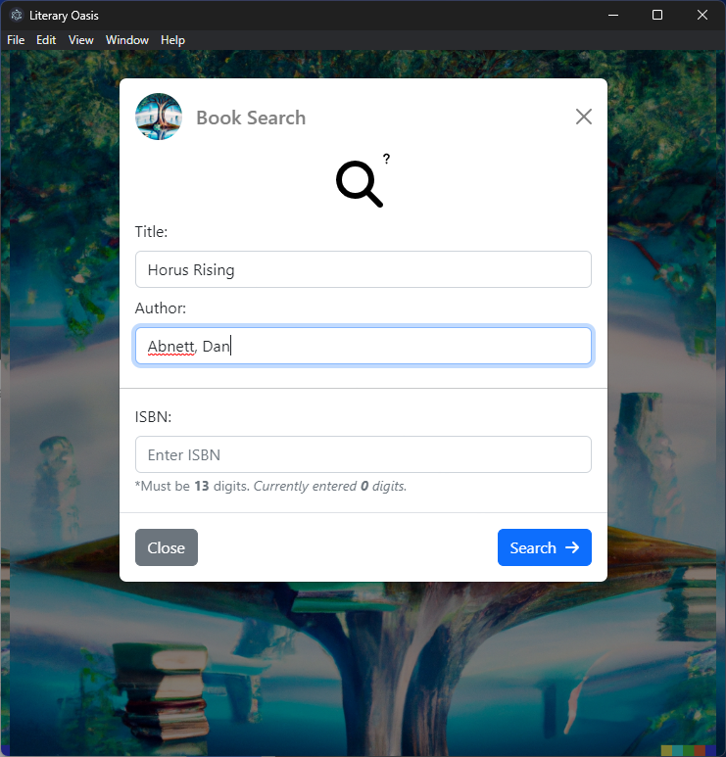If you click the book search button, you can search by Title and Author or ISBN

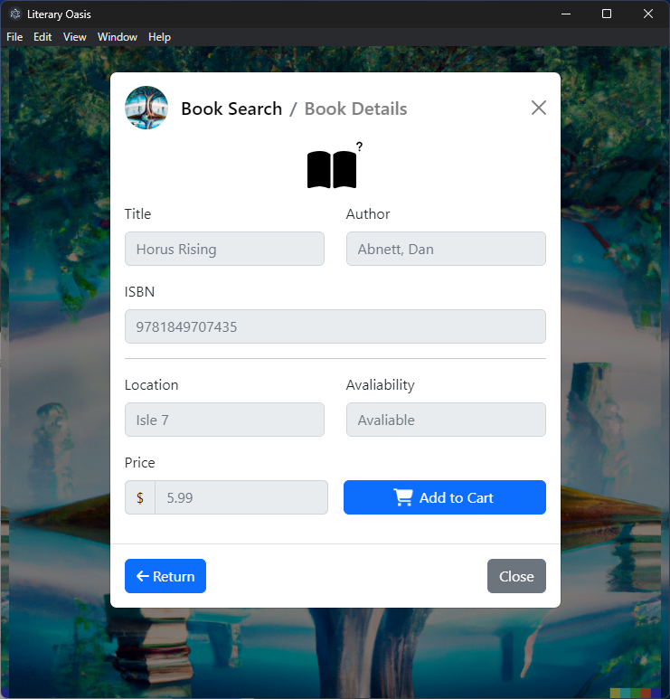

Here is the result of the query given by Book Search, add to cart will disable if the book is not found, and a conditional statement will appear if the book is out of stock and will be automatically ordered.

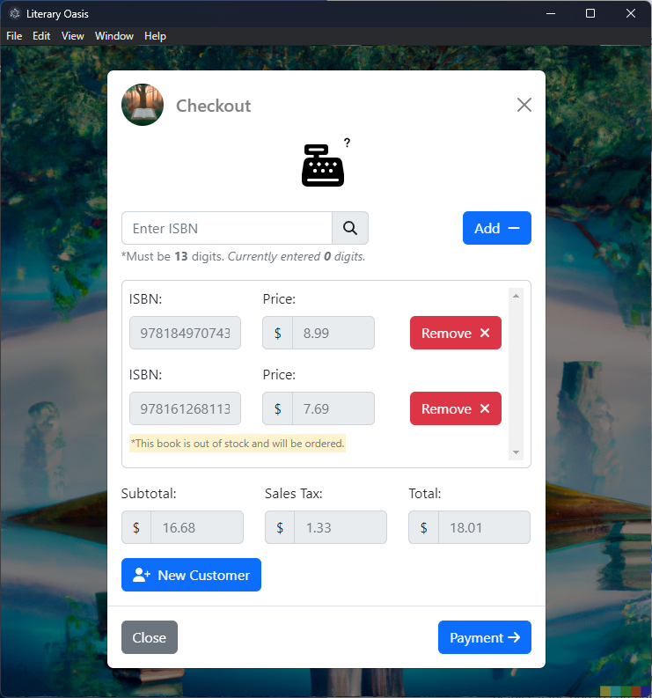

This page can be accessed by either the home screen button, or clicking add to cart in book details. If the add to cart button is clicked then the ISBN of the book is brought over to the cart. A conditional statement will appear informing the user if there is an item in their order out of stock.

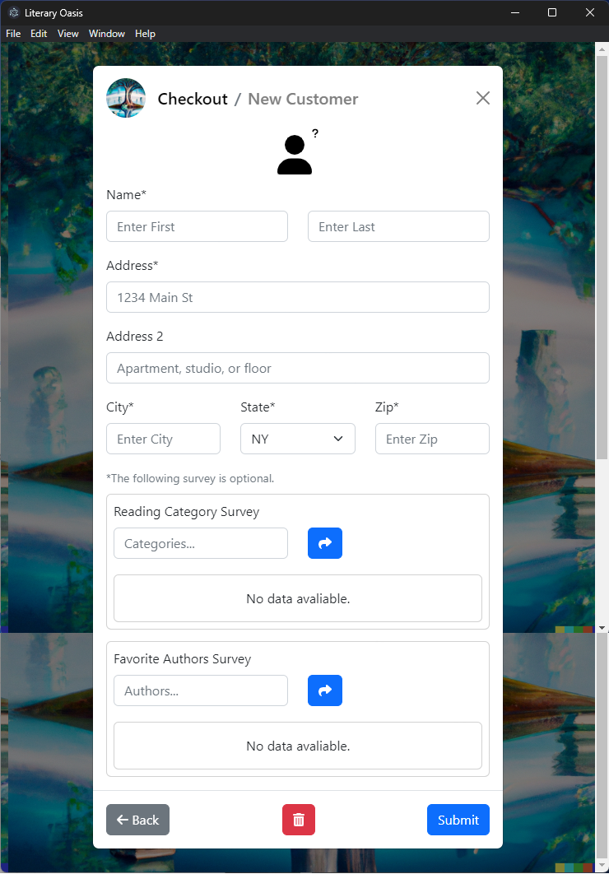

New Customer is accessed by clicking the new customer button in the checkout. Here the new customer fills out a form, and can fill out the optional survey. The trash can clears form inputs and proper form handling is in place.

[Payment screen on next page]

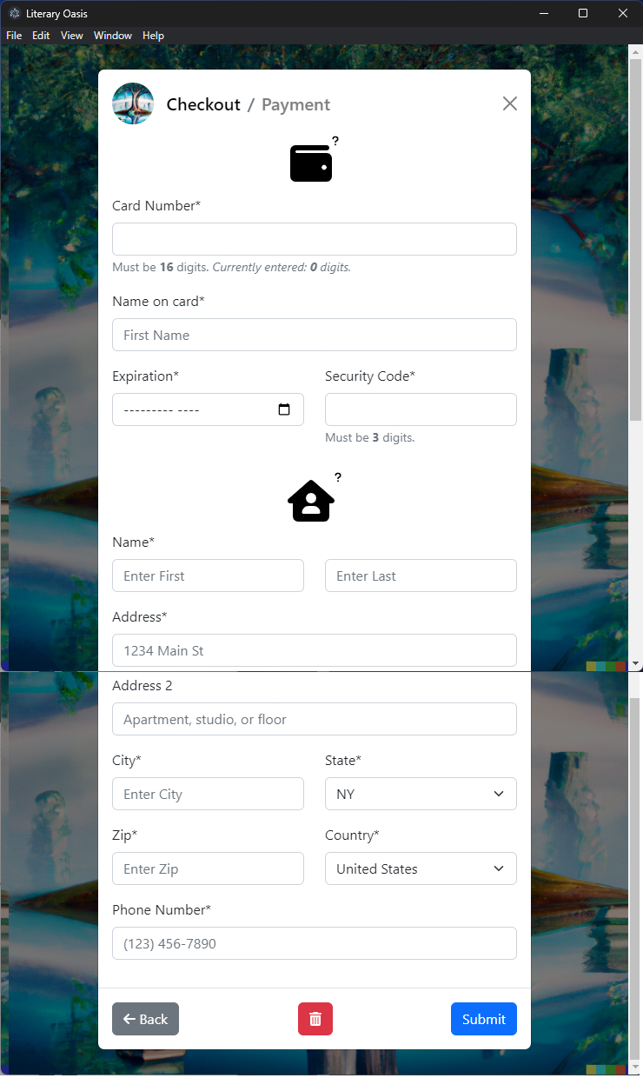

Payment screen is accessed when there is at least one book in the cart. Once the form is filled out, click submit to submit payment for the order. The trash can clears the form and form handling is in place.

### Demo video:

[LiteraryOasis-demo5.webm](https://brockportsuny-my.sharepoint.com/:v:/g/personal/kmuel4_brockport_edu/EYa3glXvvMhOg4gj86XYcbIBY5p6DW6dWsCTfPTr0VDmkQ?e=apmtKO)